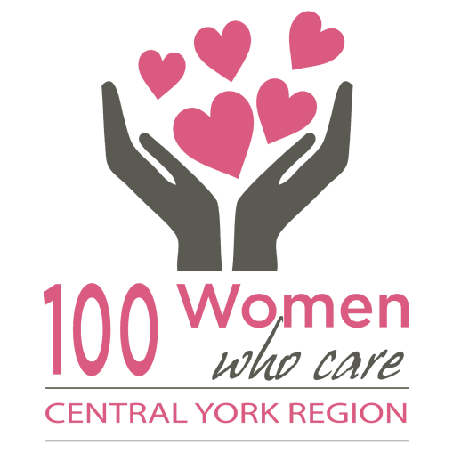
COMMITMENT
I understand that I am making a commitment to 100 Women Who Care Central York Region to make an annual donation of $400 – ($100 at each of the four meetings) – given directly to local not for profit, charities. I agree to fulfill my donation commitment even if I did not vote for the charity selected by majority vote. I also agree that I will provide my cheque to another member to deliver in my place if I am not able to attend a quarterly meeting.
Name:
Address:
Phone:
Email:
I agree to have my contact information included in the 100 Women Who Care Central York Region Membership Directory: Yes No
Signature:

Completed Commitment Forms may be scanned and sent via e-mail to 100womenwhocarecentralyorkregn@gmail.com, or forms may be completed and turned in at a meeting. Should you wish to discontinue membership at any time, please send an e-mail to the above address indicating your withdrawal.
If you are making a Commitment as part of a team, each person should complete a commitment form individually with their information above and complete info below:
Team total MUST be $100.00 each meeting. Only teams of 2 or 4. One team member must be named as lead and will ensure that ALL cheques are there when they arrive at a meeting or that person will ensure that they will be responsible for gathering up all cheques and have them delivered to the 100 Women CYR group no later than the Friday following a meeting.
TEAM NAME: ________________________________________
First Name: ______________________________ $25.00 $50.00 (circle one) team leader
First Name: ______________________________ $25.00 $50.00 (circle one)
First Name: ______________________________ $25.00 (circle one)
First Name: ______________________________ $25.00 (circle one)
100 Women Who Care Central York Region thanks you for your support!

